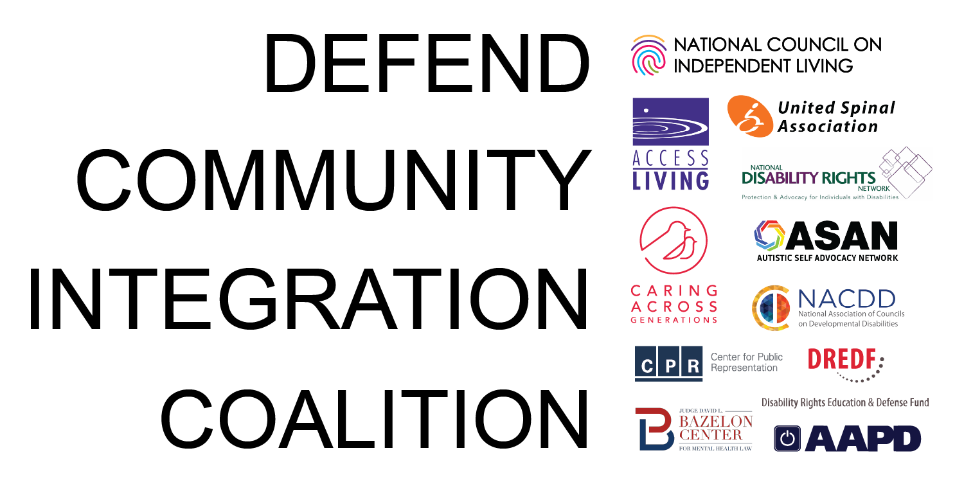

Defend Community Integration Coalition Statement on Texas v. Kennedy Proposed Joint Resolution

The Defend Community Integration Coalition (DCIC) strongly condemns the recent proposed joint resolution filed August 31 in the ongoing case Texas v. Kennedy. The proposed resolution aims to strike down the 2024 community integration regulations under Section 504 of the Rehabilitation Act of 1973. This action flies in the face of decades of judicial precedent and Congressional intent to ensure that community integration remains a civil right for all people with disabilities.

As national disability rights leaders and allies, we have worked hard for decades to advance community integration as a foundational civil right for people with disabilities. We condemn any attacks aimed at undoing this work led by and for people with disabilities.

For people with disabilities, there is no right more foundational than the right to make our own choices. Far too often, we find ourselves in the position where others decide our lives for us. It takes a lot to ensure that the choices we have are real choices. It has taken years to build the supports we need to go to school, work, eat, stay housed, and raise our children.

As humans, we deserve the security of knowing that we have what we need to live our lives.

Life is not just about getting three square meals a day and getting our meds on time. It is about growing, working, loving, dreaming, failing and reaching our potential. It is about deciding when to get up, when to go out, what to eat, and with whom to live. It is hard to do these things when we are forced to stay in congregate settings where we have no say over most aspects of our lives.

Disabled people are survivors. We are spouses, parents, siblings, classmates, colleagues, and neighbors. Most of all, we are Americans determined to fight back against ideas and actions that take away our dignity and roll back years of hard-fought progress and rights.

As a coalition we will continue to work together and fight for the full realization of the community integration mandate. Community integration of people with disabilities is non-negotiable.

This is a monumental fight. In a moment like this, we need to join forces and work collectively. We are stronger together.

Join the Defend Community Integration Coalition: https://bit.ly/3V8NfIy

Additional Resources and Calls to Action

1. AAPD’s webinar “Understanding and Protecting Your Disability Rights Under Olmstead, the ADA, and Section 504” and action steps: https://bit.ly/4gCGaHi

2. Statement of National Disability Organizations on the Proposed Resolution: https://bit.ly/4zTYapt

3. DREDF’s Resource Page: https://bit.ly/4h78eEf

4. An excellent summary from Red Line for Civil Rights: https://bit.ly/4qNSTeZ

DCIC’s membership is comprised of Access Living, American Association of People with Disabilities, Autistic Self Advocacy Network, Bazelon Center for Mental Health Law, Caring Across Generations, Center for Public Representation, Disability Rights Education & Defense Fund, National Association of Councils on Developmental Disabilities, National Council on Independent Living, National Disability Rights Network, and United Spinal Association.

Image: Coalition Graphic. Text reads, “Defend Community Integration Coalition” followed by logos for NCIL, AAPD, ASAN, Caring Across Generations, NDRN, United Spinal, Access Living, NACDD, Center for Public Representation, Bazelon Center for Mental Health Law, and DREDF.

