Developmental Disabilities Awareness Month Resource Guide 2024

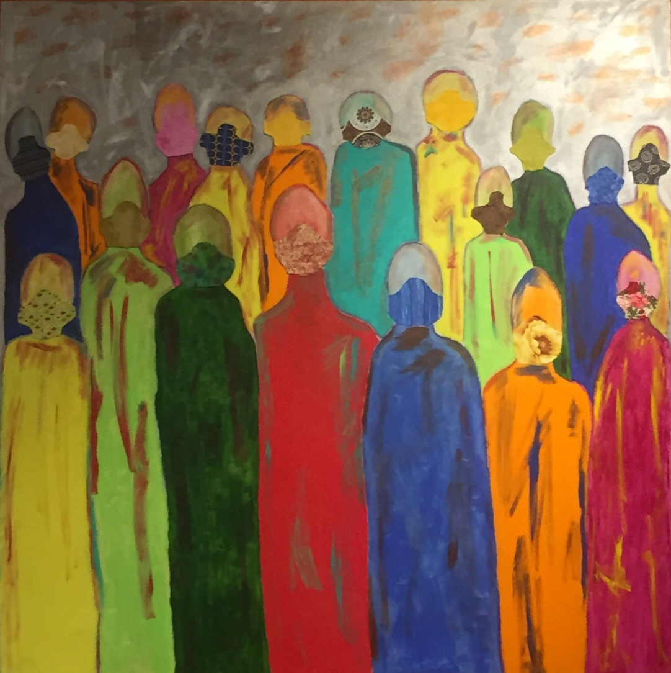

Artwork by Lee Waters, “What?”

  - Developmental Disabilities Awareness Month
This resource guide is intended to help provide content for posting on social media during Developmental Disabilities Awareness Month (March 2023). There are no set guidelines for posting – feel free to share whatever you want, whenever you want! For more information about DD Awareness Month, or if you need help posting to social media, please visit: https://nacdd.org/ddam1/

  - DD Awareness Month 2024 Theme: A World of Opportunities
The Theme for DD Awareness Month 2024 is “A World of Opportunities.” We are celebrating people and working together to remove obstacles. Our goal is to build a community that’s committed to creating a world where everyone can do well and succeed. Join us in making a world where all kinds of people have the chance to thrive.

Who to Follow on Social Media:

- NACDD
  - Facebook
  - Twitter (X)
  - LinkedIn
  - YouTube
  - Instagram

- ACL
  - Facebook
  - Twitter (X)
  - LinkedIn
  - YouTube

- Remember to use the hashtags #DDAwareness2024, #DDAM, #DDAM2024, & #NewOpportunities Every organization reading this guide has stories to share, and DDAM is our yearly opportunity to share far beyond our individual networks.
- Generally, anything that is tagged with #DDawareness2024, #DDAM, #DDAM2024, & #NewOpportunities is free to be liked, commented on, and shared/retweeted. Our advice on re-sharing: use it as an excuse to reach out to groups and ask their staff to share your organization’s DD Awareness Month posts as well.
- DD Awareness Month is a wonderful opportunity to share and promote art created by people with developmental disabilities.
- Keep track of the data connected to how many people your posts reach, as well as how many people react to them. This will help you measure and show the impact of the campaign.
- This resource guide will be updated every Monday throughout March. If you have or know of a resource that you want to be included, please email Rafa Rolon-Muniz at rrolon-muniz@nacdd.org, or Robin Troutman at rtroutman@nacdd.org.
- We have created a logo this year that you are free to use however you want. Credit for the artwork should go to Lee Waters. You can download them directly from this guide or find them on our DDAM webpage.
- We have the logo in 6 additional languages. Check out the DDAM page to find the logos in Spanish, Cantonese, French, Italian, Japanese and Arabic.

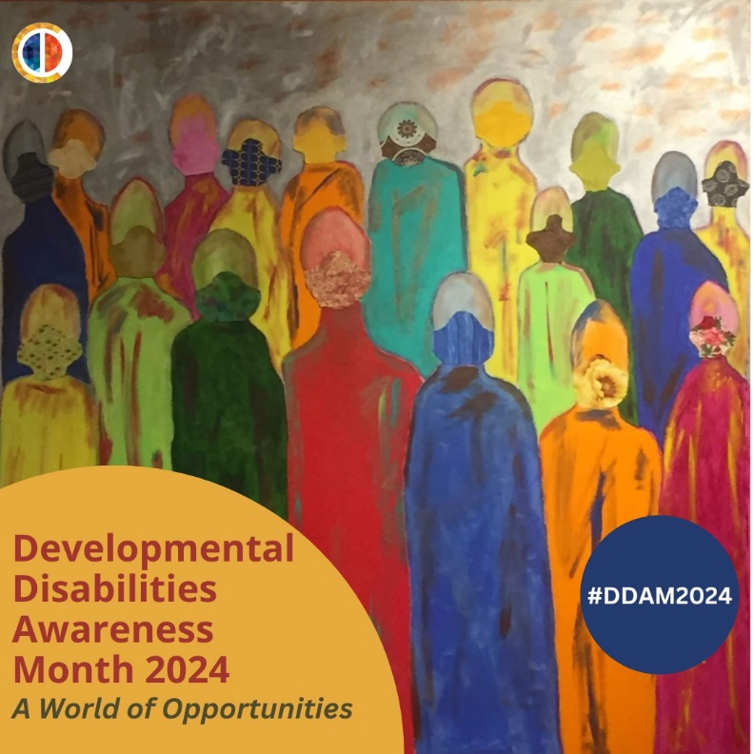

Messaging Advice:

Whether your organization is a self-advocacy group that has been advocating for disability rights for decades, a state council on developmental disabilities, or a corporation that is just introducing its members to the disability community, we believe that everyone is a welcome addition to celebrating this month. We simply ask that organizations participating in this campaign keep a few guidelines in mind if they share stories attached to the campaign:
- Stories should include (and ideally focus on) individuals with developmental disabilities. The disability community is wide and includes family members, support professionals, friends, etc. that also deserve to be celebrated, but it is impossible to authentically promote awareness of developmental disabilities without including the people with these disabilities.
- Any posts connected to DD Awareness Month should be supportive and not negative or combative towards other disability organizations. Our community is diverse, and, like all communities, it includes members that disagree with each other on certain issues. Health debate absolutely has a place in our community, as does calling attention to problems that need to be solved. However, awareness campaign posts are usually not the appropriate time or place for these debates, as it takes the focus away from the individuals and groups that the campaign should be celebrating.
- Do not forget to connect posts to the programs or organizations that are improving our community. The framing of stories is a complicated yet important subject. To keep our advice short, we just remind you to “connect the dots” between successful stories and the programs that caused the successes. Similarly, it can be effective to connect the dots between obstacles and the work that needs to be done to fix them.

Social Media Example

These two tweets from prior DD Awareness Month campaign are examples of the type of story sharing that fits the vision of the awareness month campaign. The tweets also connect the dots between the stories and the two different programs that they were involved in (Microsoft’s Supported Employment program and SSA’s Ticket to Work). Most importantly, they focus on the benefits of their programs instead of attacking others.

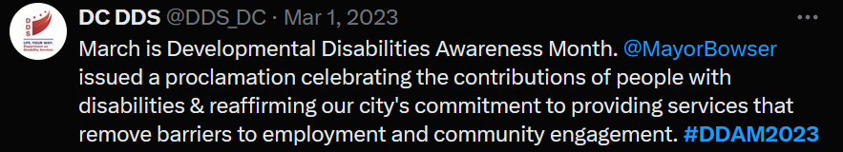

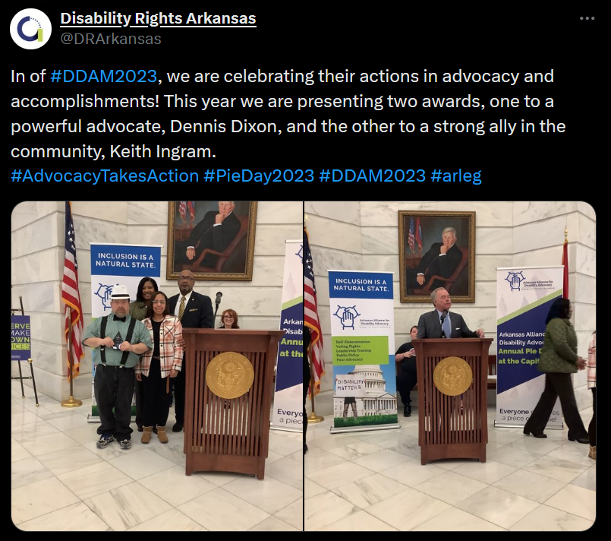

Tweet 1 (By @DDS_DC) – “March is Developmental Disabilities Awareness Month.
@MayorBowser issued a proclamation celebrating the contributions of people with disabilities & reaffirming our city's commitment to providing services that remove barriers to employment and community engagement. #DDAM2023”

Tweet 2 (By @DRArkansas) – “In of #DDAM2023, we are celebrating their actions in advocacy and accomplishments! This year we are presenting two awards, one to a powerful advocate, Dennis Dixon, and the other to a strong ally in the community, Keith Ingram. #AdvocacyTakesAction #PieDay2023 #DDAM2023 #arleg”

Social Media Opportunity

Interested in having your organization’s social media listed here? Contact Rafa Rolon-Muniz at rrolon-Muniz@nacdd.org, or Robin Troutman at rtroutman@nacdd.org, and we will list it here!

PARTICIPATE/PROMOTE:

When an organization is holding a March event, we encourage everyone to promote and share posts about that event even if it is on the other side of the country! Sharing news and posts about events that are happening around the country can be an effective way to highlight the national scope of DD Awareness Month for your local networks.

While you will likely learn about many more events simply through following a wide range of groups on social media, we will also list any events that we know about here so you can plan with posts. If you’re planning a March event, big or small, please let us know if you would like us to add it to this list

Looking Forward – April is National Autism Awareness Month
Building awareness doesn’t end on March 31st! At the beginning of April, we pass the torch to the Autism Society, as they lead the national awareness campaign for autism. They challenge you to #CelebrateDifferences in your community and get involved for NAAM, joining their mission to spread awareness, promote acceptance and ignite change! Share their resources in your classroom or store front, engage your employees in fundraising efforts, or attend an event. \

Autism Society Social Media Platforms:

- Facebook
- Twitter (X)
- Instagram
- LinkedIn
- YouTube

Resource Guide

Podcast

- BoggsCast - A podcast from The Boggs Center on Developmental Disabilities where faculty and staff explore best practice, showcase success stories, and help listeners envision possibilities for innovation through interviews with state and national experts.
- Develop Abilities - Are you a person with a disability that wants to learn more about how to be a better advocate and to learn more about life as a self-advocate? Are you a family member of someone living with a disability who wants to hear about how to support your loved one? Are you a community member interested in inclusion? If you said yes to any of those questions, then this podcast is for you! Join advocates from Utah to learn about issues impacting the disability community, and about how self-advocates are working to Develop Abilities.
- Disability After Dark - Hosted by Disability Awareness Consultant Andrew Gurza; this podcast that looks at disability stories.
- Disability Visibility - a podcast hosted by Alice Wong featuring conversations on politics, culture, and media with disabled people.
- Disarming Disability - The podcast's mission is to powerfully deconstruct disability through candid conversations with experts exploring topics related to disability. The podcast looks to educate, empower, voice, and build a more inclusive society.
- Down to the Struts - Qudsiya Naqui is a lawyer and activist living in Washington DC. She identifies as a blind, South Asian woman, and is dedicated to making spaces and systems more inclusive of disabled people through public education, storytelling, and amplifying the voices of disabled people.
- Impact – The Conversation - conversations around critical topics in disability
- Included: The Disability Equity Podcast - A podcast from the Johns Hopkins Unive.rsity Disability Health Research Center that challenges stereotypes of disability by sharing stories, data, and news.
- Including You: A Disability Rights Arkansas Podcast - Disability Rights Arkansas, we are focused on guidance for people with disabilities – navigating your rights, things that help with your everyday life, and navigating the complex systems of how to get the support you need.
- OurView: Disability Awareness At OurView, we aim to raise awareness, educate, and change the tone of conversations about disabilities, and those who live with disabilities.
- Power Not Pity – The podcast explores the lives of disabled people of color everywhere! Through storytelling, commentary and analysis, the podcast aims to amplify the lived experiences and perspectives of disabled people.
- The Accessible Stall - podcast by Emily Ladau and Kyle Khachadurian. This podcast keeps it real about issues within the disability community.

Do you have or know of a podcast that you would like to be included in our DD Awareness Guide? Send it to NACDD staff!

Videos

- Accessibility is for Everyone (2018) - NV DD Council
- Breaking Barriers of Autism: The Power of Kindness and Friendship | Benjamin Tarasewicz – TEDx Talks
- Caregiving Across the Continuum (2020) – Think + Charge
- Claws & Wings (2020) - Delaware DDC
- Conversations on Showing Up for Kids! – CYSHCN
- Delaware disability pride Media Campaign Fall compilation 2022 – Delaware DD Council
- Disability Inclusion in the Workplace (2018) - New York State Developmental Disabilities Planning Council
- Down Syndrome Didn’t Stop Me Becoming A Cheerleader | BORN DIFFERENT (2019) – Truly
- The Spirit of Individual Enterprise and Economic Inclusion - RIDDC
- Acknowledging Developmental Disabilities Awareness Month / Unmet: NC's Disability Crisis - North Carolina Council on Developmental Disabilities
- Dream project @ Home (2020) – National Dance Institute
- I Dream of a World (2020) - Informing Families
- Employment Matters – Seven Hills
- Everyone Wins When Everyone's Included! (2018) - Informing Families
- Healthy Boundaries Lesson – Elevatus Training
- Hear Me! People with Developmental Disabilities Speak Out (2017) - NV DD Council
- Housing Opportunities that Help Promote Independent Living (2019) - New York State Developmental Disabilities Planning Council
- Inclusion Today, Community Living for Life (2019) – Georgetown UCEDD
- Interview with Second Story Press (2021) – Rita Winkler
- It’s All About Attitude (2019) - Institute on Human Development & Disability / UGA
- My Autistic Friend Explains Autism (And Why He's Proud to be Autistic) (2018) - Special Books by Special Kids
- Niko's Story (2019) - DRO social media
- Redefining Inclusion (2018) - Taishoff Center
- RIDDC Small Business Classes - RIDDC
- Small Business Saturday SBSSHOPRI 2023 Event - RIDDC
- Treat me like everyone else | Self-Determintion | WI Board for People w/ Develop. Disabilities - Self-Determination Channel
- The Judith Campaign - Amplifying Voices, Honoring Truth – DC DD Council
- Voting in Local Elections | Self-Determination | WBPDD - Self-Determination Channel
- What Women With Autism Want You to Know (2018) – Iris

Do you have or know of a video that you would like to be included in our DD Awareness Guide? Send it to NACDD staff!

Toolkits

- Are you In? Campaign – Virginia Developmental Disabilities Council
- The Arc of Monmouth Resources - Advocacy and Resources – The Arc of Monmouth
- Art Access - Art Access increases access to the arts in Utah through creative opportunities for artists with disabilities and accessibility education and resources.
- All Brains Belong VT - a Primary Care & Community organization located in Montpelier, Vermont who use principles of inclusive design to offer healthcare and community connection.
- Can You Hear Me Now? Listening to Adults with ID in Health – The Ohio State University
- Communicate and create your way: What’s new in Microsoft 365 Accessibility for October-December 2022 - Aleš Holeček
- Creative Like Me - a collaboration between Fulton County Arts and Culture (FCAC) through the Public Art Program, and the Department of Behavioral Health and Developmental Disabilities (BHDD).
- Emergency Power Planning for People Who Use Electricity and Battery-Dependent Assistive Technology and Medical Devices – FEMA
- Empowerment and Leadership - Third EDF Manifesto on the Rights of Women and Girls with Disabilities – European Disability Forum
- “It’s Time for a Reimagining of Disability Etiquette - Forbes
- One Workforce: Inclusive Employment in North Carolina - a digital look book from the North Carolina Council on Developmental Disabilities.
- My name is Rita
- Microsoft Inclusive Design - Microsoft
- Navigating Workforce More Challenging For Those With Disabilities, Advocates Say
- Self Advocacy Start-Up Toolkit: More Power, More Control Over our Lives! - Self Advocates Becoming Empowered
- Stephan Soares’ Story - Community Access Unlimited. Read Stephan’s story about perusing his lifelong goal of being a truck driver
- Road to Disability Inclusive Report – Disability and Philantropy Forum
- Tips4Inclusion
- SCDD – Storyteller’s Blog - the Communications Unit of the California State Council on Developmental Disabilities’ created the Storytellers blog to be a platform where we share triumphs and setbacks—determination and resilience—through the experiences of people with intellectual and developmental disabilities who break through barriers and forge their paths forward. Storytellers share their experiences, insights, and lessons learned through first-person perspectives, interviews, articles, spotlights, and videos.
- SCDD - Tracking the Transition out of the 14c Subminimum Wage Program -The purpose of this annual report is to track the progress of the Multi-Year Subminimum Wage Phaseout Plan recommendations published by the California State Council on Developmental Disabilities (SCDD) in January 2023 as required by SB 639
- SCDD - There Should Be a Law Report 2023: 3rd Annual Contest Results - In 2021, the California State Council on Developmental Disabilities created the annual There Should Be a Law Contest! This contest encourages California residents to participate in systems change advocacy by suggesting ways to improve daily life for people with disabilities by proposing new legislation or changes to existing legislation.
- Inclusive Healthcare Partnership Project – IHPP believe that everyone should have the tools they need to support their own health. This includes health information that is easy to understand. It also means that healthcare providers are prepared to work with patients with a wide range of disabilities.
- Super Smiles for your Child - Oral Health Kansas has created a new web experience for families with young children. Explore Super Smiles for Your Child together to watch fun videos, test your knowledge with exciting games, and listen to children’s books that will provide you with great edutainment.
- Student group's workshop aims to overcome barriers - By John Keenan of UNMC. An example of a higher-education program profile with a focus on its participants
- Talking about Healthy Relationships - Elevatus Training.
- Finding Your Way: A Navigation Guide for Wisconsin Families Who Have Children and Youth with Special Health Care Needs and Disabilities - designed to help families and professionals navigate the system of care in Wisconsin.
- Pittsverse Magazine - quarterly publication written exclusively by adults diagnosed with autism spectrum disorder that aims to increase inclusion and broaden the general understanding of autism
- Progressive Art Studio Collective
- Programs and Supports - College Experience - Kach – The Arc of Monmouth
- Programs and Supports - Health Services – The Arc of Monmouth
- Programs and Supports - Recreation – The Arc of Monmouth
- Programs and Supports - Adult Services – The Arc of Monmouth
- Progressive Art Studio Collective - Progressive Art Studio Collective (PASC), launched in 2021, is a dedicated art and design studio with a professional gallery for disabled artists or artists with disabilities, serving Detroit/Wayne County.
- We Do Life Together - an organization in Connecticut dedicated to supporting individuals with intellectual disabilities reach their full potential.

Do you have or know of a news article, blog post, personal story, toolkit, etc. that you would like to be included in our DD Awareness Guide? Send it to NACDD staff!

News

- Books Honored For Disability Storylines – Disability Scoop
- Businesses praise work of developmentally disabled - The Tahlequah Daily Press
- Disabled Workers Shatter Employment Myths - The Laconia Daily Sun
- 15 inclusive books by disabled women writers by Disability Horizon
- Davos: Employees with Disabilities on the Agenda by TravelAbility
- It’s Time for a Reimagining of Disability Etiquette – Forbes
- People with Disabilities Report Fewer Voting Troubles - Disability Scoop
- Prosecutor starts first N.J. program to train people with special needs to work in law enforcement - NJ.com
- Transforming Impossible to Possible: Josh's Journey to Success - Perspectives Corporation
- 100 Women of the Year: Judith Heumann - Time Magazine
- The ADA is Turning 30. Here’s What You Should Know – Changing America
- Random Acts of Kindness Kick Off DDAM – The Citizens’ Voice
- This Craft Brew Pub Thrives, Thanks to a Secret Ingredient: Workers with Disabilities - Los Angeles Times
- What Companies Gain by Including Persons with Disabilities – World Economic Forum
- How Educators Secretly Remove Students With Disabilities From School – The New York Times
- Dream Come True: 80 Years in the Making – SpArc Philadelphia
- It’s Time To Stop Even Casually Misusing Disability Words - Forbes
- Opinion: Reimagining paratransit requires federal leadership and funding – City&State New York

COVID-19 Resource

While numerous organizations have created, gathered, and/or promoted COVID-19 (coronavirus) general resources, it’s important to share I/DD-specific resources as well given the virus’s potential impact on people with compromised immune systems or other such complications that lead to increased risk. A significant percentage of people with I/DD fall into this category, and many more are at risk if the pandemic disrupts the Direct Support Professional (DSP) workforce or overtaxes the healthcare system.

If it makes sense for you to use DD Awareness Month as a context or reason to share DD-specific COVID-19 resources, please go ahead and share away. It is extremely important to counteract the narrative that the virus’s danger is overblown because of its low mortality rates with younger adults without previous respiratory issues. The type of person-focused stories that are often shared during DD Awareness Month can be an effective complement to these resources, as it can help everyone become better able to view people with I/DD as individuals and not as a group or demographic.

Below are some resources you can share. For those interested in state-specific resources, we encourage you to contact one of the state’s DD Act organizations (the DD Council, Protection and Advocacy, or University Center for Excellence in Developmental Disabilities).

- Get Out The Vaccine: NACDD campaign with the goal to provide people with I/DD, their families, and their communities with resources. With this campaign, the goal is to provide relevant and accurate up-to-date information on the COVID-19 vaccine.
- Disability-focused Information: The ACL COVID-19 page has put together a list of disability-related COVID-19 information and resources. It is updated regularly.
- Medicaid: The Centers for Medicare & Medicaid Services have a list of Frequently Asked Questions and other resources about Medicaid and CHIP programs.
- Plain-Language Information: The Green Mountain Self-Advocates and the Vermont DD Council have a plain-language guide to COVID-19 set at a 3rd-grade reading level.
- General Information: The CDC COVID-19 page is the most reliable source of general information about the virus. It is updated regularly.
- The National Center for Learning Disabilities (NCLD) the CERES Institute for Children & Youth at Boston University Wheelock College of Education & Human Development to examine general educators’ experiences during the COVID-19 pandemic, with a specific focus on their experiences instructing students with learning and attention issues. To read the full report, click here.

Proclamation Guidelines and Tips

State Contact links
- Alabama - https://contact.governor.alabama.gov/contact_procs.aspx
- Alaska - http://aws.state.ak.us/CrmForms/Home/WebRequest
- American Samoa -
- Arizona - https://azgovernor.gov/engage/form/proclamation-request
- Arkansas - https://governor.arkansas.gov/online-services/proclamation-request/
- California - Must be evaluated and sponsored by the state agency under which the proclamation topic falls. The agency works directly with the requestor to determine if the agency will sponsor the proclamation. Contact dmarsalek@counseling.org for help filing this proclamation.
- Commonwealth of the Northern Marianas Islands - https://www.archives.gov/federal-register/codification/chapter.html
- Colorado - https://www.colorado.gov/governor/proclamations
Connecticut - https://portal.ct.gov/Office-of-the-Governor/Contact/Request-a-proclamation
- District of Columbia - https://os.dc.gov/service/ceremonial-services
- Delaware - https://governor.delaware.gov/request-proclamation-tribute/
- Florida - https://www.flgov.com/proclamations/
- Georgia - https://gov.georgia.gov/webform/proclamation-request-form
- Guam - Contact dmarsalek@counseling.org for help filing this proclamation
- Hawaii - https://governor.hawaii.gov/contact-us/request-a-commemorative-message/
- Idaho - https://gov.idaho.gov/contact/proclamations/
- Illinois - https://www2.illinois.gov/gov/contactus/Pages/Proclamation.aspx
- Indiana - https://www.in.gov/gov/2916.htm
- Iowa - https://governor.iowa.gov/services/request-proclamation
- Kansas - https://governor.kansas.gov/serving-kansans/constituent_services/proclamation-guidelines/proclamation-request/
- Kentucky - https://secure.kentucky.gov/formservices/Governor/ProclamationRequestForm
- Louisiana - http://gov.louisiana.gov/index.cfm/form/home/13
- Maine - https://www.maine.gov/governor/mills/contact/request_proclamation
- Maryland - https://md.accessgov.com/governor/Forms/Page/cs/letter/1
- Massachusetts - https://www.mass.gov/forms/request-a-proclamation-from-governor-healey
- Michigan - https://www.michigan.gov/snyder/0,4668,7-277-57577_59874---,00.html
- Minnesota - http://mn.gov/gov-stat/pdf/proclamation_request_form_updated_2018_tcm1055-322488.pdf
- Mississippi - http://www.governorbryant.com/requests/proclamation-request/
- Missouri - https://governor.mo.gov/contact-us
- Montana - https://montana.servicenowservices.com/gov?id=sc_cat_item&sys_id=553540f11bca5d100b73a8efe54bcb7f
- Nebraska - https://governor.nebraska.gov/proclamation-request
- Nevada - https://gov.nv.gov/Forms/Request_a_Proclamation/
- New Hampshire - https://new-hampshire.secure.force.com/support/GOV_Proclamation
- New Jersey - https://nj.gov/governor/contact/proclamations
- New Mexico - https://www.governor.state.nm.us/contact-the-governor/requesting-a-proclamation/
- New York - https://www.governor.ny.gov/content/governor-contact-form
- North Carolina - https://governor.nc.gov/request/request-proclamation
- North Dakota - https://www.governor.nd.gov/media-center/proclamations
- Ohio - https://governor.ohio.gov/contact/recognition-request
- Oklahoma - https://oklahoma.gov/governor/contact/commendation-or-proclamation.html
- Oregon - https://www.oregon.gov/gov/Pages/Proclamation-Request-Guidelines.aspx
- Pennsylvania - https://www.governor.pa.gov/contact/
- Puerto Rico - https://www.statedepartment.pr.gov/proclamations
- Rhode Island - http://www.governor.ri.gov/contact/
- South Carolina - https://governor.sc.gov/contact-governors-office
- South Dakota - https://iqconnect.lmhostediq.com/iqextranet/EForm.aspx?__cid=FSL_SD_GOV&__fid=2100080
- Tennessee - https://www.tn.gov/governor/contact-us/constituent-requests/proclamation-request.html
- Texas - https://gov.texas.gov/organization/military/contact_tmpc
- Utah - https://governor.utah.gov/declarations/
- Vermont - https://governor.vermont.gov/proclamation-request
- Virginia - https://www.governor.virginia.gov/constituent-services/request-a-proclamation/
- Virgin Islands - https://www.vi.gov/contact/
- Washington - https://www.governor.wa.gov/contact/requests-invites/request-ceremonial-proclamation-greeting-or-letter
- West Virginia - https://appengine.egov.com/apps/wv/governor/request-proclamation
- Wisconsin - https://evers.wi.gov/Pages/Newsroom/Proclamations.aspx
- Wyoming - https://governor.wyo.gov/contact/proclamation-requests

Instructions and Tips
- Make your case – Why is this important and why do people need to pay attention? Describe what DDAM matters and why states should have a proclamation or equivalent during the month.
- Who is your Contact? – Find out who is the best contact in your state. That contact may be in charge of or connected to the development of the proclamations. Build a connection with them as they can be your best asset when drafting language in your request.
- Have draft language approved by your partners!
- Understand your states timeline for accepting requests.
- Ensure you get both a digital and physical copy of the proclamation for your records.

Examples

