Developmental Disabilities Awareness Month Resource Guide 2023

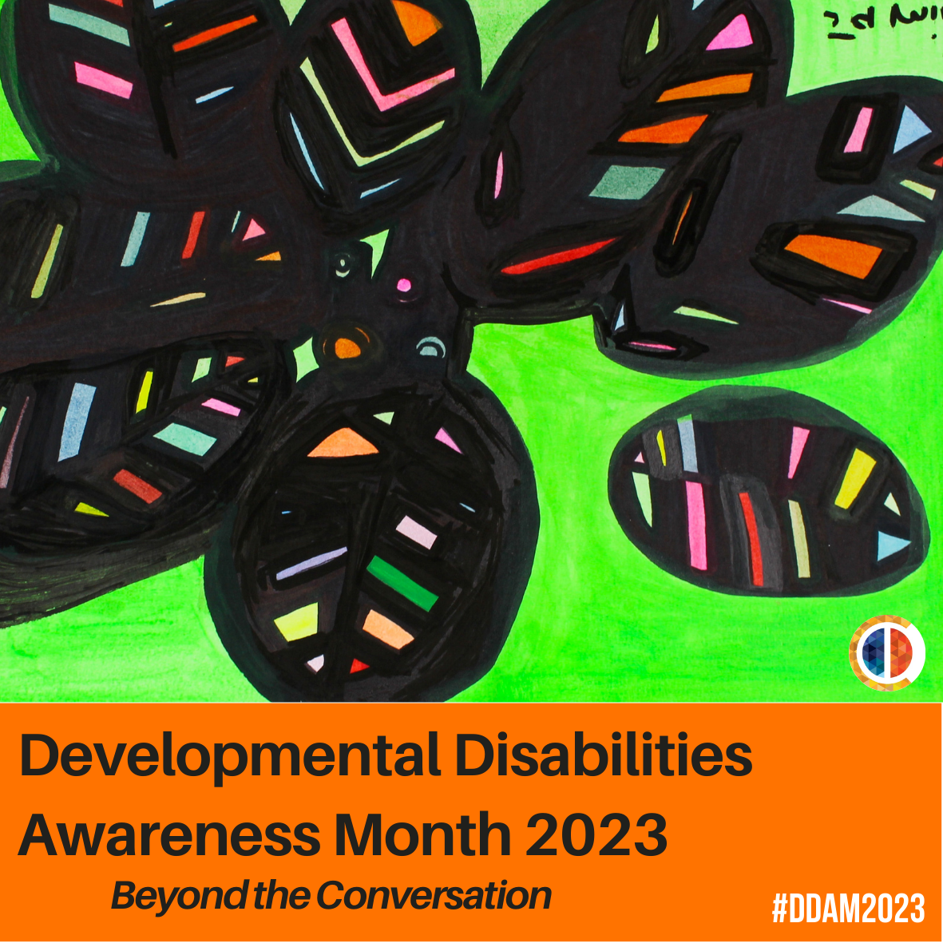
Artwork by Jamila Rahimi/Art Enables

  - Developmental Disabilities Awareness Month
This resource guide is intended to help provide content for posting on social media during Developmental Disabilities Awareness Month (March 2023). There are no set guidelines for posting – feel free to share whatever you want, whenever you want! For more information about DD Awareness Month, or if you need help posting to social media, please visit: https://nacdd.org/ddam1/

  - DD Awareness Month 2023 Theme: Beyond the Conversation
The Theme for DD Awareness Month 2023 is “Beyond the Conversation.” It is time to ask the question, “Once the conversations have taken place, what comes next?” What comes next is action. What are communities doing to create change? So, simply said, the time for talking is over, now it is time for us to act to create this change.

Who to Follow on Social Media:

- NACDD
  - Facebook
  - Twitter
  - LinkedIn
  - YouTube
  - Instagram

- AUCD
  - Facebook
  - Twitter
  - YouTube
- NDRN
  - Facebook
  - Twitter
  - YouTube
- State Directory
  - List of State DD Councils
  - List of P&A Agency
  - List of State UCEDDS

General Points

- Remember to use the hashtags #DDAwareness2023, #DDAM/, #DDAM2023, & #BeyondtheConversation Every organization reading this guide has stories to share, and DDAM is our yearly opportunity to share far beyond our individual networks.
- Generally, anything that is tagged with #DDawareness2023, #DDAM, #DDAM2023, & #BeyondtheConversation is free to be liked, commented on, and shared/retweeted. Our advice on re-sharing: use it as an excuse to reach out to groups and ask their staff to share your organization’s DD Awareness Month posts as well.
- DD Awareness Month is a wonderful opportunity to share and promote art created by people with developmental disabilities.
- Keep track of the data connected to how many people your posts reach, as well as how many people react to them. This will help you measure and show the impact of the campaign.
- This resource guide will be updated every Monday throughout March. If you have or know of a resource that you want to be included, please email Rafa Rolon-Muniz at rrolon-muniz@nacdd.org, David Sebastian Matos at dmatos@nacdd.org or Robin Troutman at rtroutman@nacdd.org.
- We have created a logo this year that you are free to use however you want. Credit for the artwork should go to Jamila Rahimi at the Art Enables studio in Washington DC. You can download them directly from this guide or find them on our DDAM webpage.
- We have the logo in 5 additional languages. Check out the DDAM page to find the logos in Spanish, Cantonese, French, Tagalog and Arabic

Messaging Advice:

Whether your organization is a self-advocacy group that has been advocating for disability rights for decades, a state council on developmental disabilities, or a corporation that is just introducing its members to the disability community, we believe that everyone is a welcome addition to celebrating this month. We simply ask that organizations participating in this campaign keep a few guidelines in mind if they share stories attached to the campaign:
- Stories should include (and ideally focus on) individuals with developmental disabilities. The disability community is wide and includes family members, support professionals, friends, etc. that also deserve to be celebrated, but it is impossible to authentically promote awareness of developmental disabilities without including the people with these disabilities.
- Any posts connected to DD Awareness Month should be supportive and not negative or combative towards other disability organizations. Our community is diverse, and, like all communities, it includes members that disagree with each other on certain issues. Health debate absolutely has a place in our community, as does calling attention to problems that need to be solved. However, awareness campaign posts are usually not the appropriate time or place for these debates, as it takes the focus away from the individuals and groups that the campaign should be celebrating.
- Do not forget to connect posts to the programs or organizations that are improving our community. The framing of stories is a complicated yet important subject. To keep our advice short, we just remind you to “connect the dots” between successful stories and the programs that caused the successes. Similarly, it can be effective to connect the dots between obstacles and the work that needs to be done to fix them.

Example

These two tweets from prior DD Awareness Month campaign are examples of the type of story sharing that fits the vision of the awareness month campaign. The tweets also connect the dots between the stories and the two different programs that they were involved in (Microsoft’s Supported Employment program and SSA’s Ticket to Work). Most importantly, they focus on the benefits of their programs instead of attacking others.

Tweet 1 (By Easterseals HQ) – “Did you know that developmental disabilities are disabilities that occur from birth to the first few years of development, and usually last someone’s entire life? Common developmental disabilities include: autism, cerebral palsy, down syndrome, and ADHD. #DDAM2022”

Tweet 2 (By The Arc of NJ) – “Thank you @GovMurphy & @NJDHS for recognizing March as Developmental Disabilities Awareness Month and for your ongoing support of people with intellectual and developmental disabilities! #DDAM2022”

FOLLOW

You can find a list of DD Councils on the NACDD website.

Interested in having your organization’s social media listed here? Contact Rafa Rolon-Muniz at rrolon-Muniz@nacdd.org, David Sebastian Matos at dmatos@nacdd.org or Robin Troutman at rtroutman@nacdd.org, and we will list it here!

Videos

- Accessibility is for Everyone (2018) - NV DD Council
- Breaking Barriers of Autism: The Power of Kindness and Friendship | Benjamin Tarasewicz – TEDx Talks
- Caregiving Across the Continuum (2020) – Think + Charge
- Claws & Wings (2020) - Delaware DDC
- Conversations on Showing Up for Kids! – CYSHCN
- Delaware disability pride Media Campaign Fall compilation 2022 – Delaware DD Council
- Developmental Disabilities Awareness Day (2020) – APD Florida (2020) – APD Florida
- Disability Inclusion in the Workplace (2018) - New York State Developmental Disabilities Planning Council
- Down Syndrome Didn’t Stop Me Becoming A Cheerleader | BORN DIFFERENT (2019) – Truly
- Dream project @ Home (2020) – National Dance Institute
- I Dream of a World (2020) - Informing Families
- Employment Matters – Seven Hills
- Everyone Wins When Everyone's Included! (2018) - Informing Families
- Healthy Boundaries Lesson – Elevatus Training
- Hear Me! People with Developmental Disabilities Speak Out (2017) - NV DD Council
- Housing Opportunities that Help Promote Independent Living (2019) - New York State Developmental Disabilities Planning Council
- Inclusion Today, Community Living for Life (2019) – Georgetown UCEDD
- Interview with Second Story Press (2021) – Rita Winkler
- It’s All About Attitude (2019) - Institute on Human Development & Disability / UGA
- Listen to Robin; Baylee; and NiK! Development Pathways and Access Gallery in Colorado share the stories of 3 advocates.
- My Autistic Friend Explains Autism (And Why He's Proud to be Autistic) (2018) - Special Books by Special Kids
- Niko's Story (2019) - DRO social media
- Redefining Inclusion (2018) - Taishoff Center
- RIDDC Small Business Classes - RIDDC
- Small Business Saturday SHOP RI 2021|RIDDC
- "Treat me like everyone else" | Self-Determintion | WI Board for People w/ Develop. Disabilities - Self-Determination Channel
- Voting in Local Elections | Self-Determination | WBPDD - Self-Determination Channel
- What Women With Autism Want You to Know (2018) – Iris

Do you have or know of a video that you would like to be included in our DD Awareness Guide? Send it to NACDD staff!

Podcast

- BoggsCast, a podcast by The Boggs Center on Developmental Disabilities.
- Disability Visibility - a podcast hosted by Alice Wong featuring conversations on politics, culture, and media with disabled people.
- Disarming Disability - The podcast's mission is to powerfully deconstruct disability through candid conversations with experts exploring topics related to disability. The podcast looks to educate, empower, voice, and build a more inclusive society.
- Down to the Struts - Qudsiya Naqui is a lawyer and activist living in Washington DC. She identifies as a blind, South Asian woman, and is dedicated to making spaces and systems more inclusive of disabled people through public education, storytelling, and amplifying the voices of disabled people.
- Included: The Disability Equity Podcast - A podcast from the Johns Hopkins University Disability Health Research Center that challenges stereotypes of disability by sharing stories, data, and news.
- Including You: A Disability Rights Arkansas Podcast - Disability Rights Arkansas, we are focused on guidance for people with disabilities – navigating your rights, things that help with your everyday life, and navigating the complex systems of how to get the support you need.
- OurView: Disability Awareness At OurView, we aim to raise awareness, educate, and change the tone of conversations about disabilities, and those who live with disabilities.
- The Accessible Stall - podcast by Emily Ladau and Kyle Khachadurian. This podcast keeps it real about issues within the disability community.

Do you have or know of a podcast that you would like to be included in our DD Awareness Guide? Send it to NACDD staff!

Texts & Toolkits

- ADA National Network - The ADA National Network provides information, guidance, and training on how to implement the Americans with Disabilities Act (ADA) to support the mission of the ADA to “assure equality of opportunity, full participation, independent living, and economic self-sufficiency for individuals with disabilities.”
- Resources - Advocacy and Resources – The Arc of Monmouth
- Art Access - Art Access increases access to the arts in Utah through creative opportunities for artists with disabilities and accessibility education and resources.
- All Brains Belong VT - a Primary Care & Community organization located in Montpelier, Vermont who use principles of inclusive design to offer healthcare and community connection.
- “Books Honored For Disability Storylines” By Shawn Heasley of Disability Scoop
- Boots on the Ground: Employment Consultant Community of Practice 2021 Project Report (2021) - WISE
- Businesses praise work of developmentally disabled by Logan Curtis, from the Tahlequah Daily Press
- Can You Hear Me Now? Listening to Adults with ID in Health Research – The Ohio State University
- Communicate and create your way: What’s new in Microsoft 365 Accessibility for October-December 2022 by Aleš Holeček
- Creative Like Me-- a collaboration between Fulton County Arts and Culture (FCAC) through the Public Art Program, and the Department of Behavioral Health and Developmental Disabilities (BHDD). This award-winning initiative seeks to provide creative enrichment opportunities to BHDD clients that meet their individual learning needs.
- “Disabled Workers Shatter Employment Myths” By Roberta Baker of the Laconia Daily Sun.
- 15 inclusive books by disabled women writers by Raya Al-Jadir
- Davos: Employees with Disabilities on the Agenda by Debbie Austin
- Great Prospects, Inc.
- How Educators Secretly Remove Students With Disabilities From School by Erica Green
- “It’s Time for a Reimagining of Disability Etiquette” By writer and #CripTheVote co-founder Andrew Pulrang. He writes regularly for Forbes.com (including the linked example).
- “One Workforce: Inclusive Employment in North Carolina,” a digital look book from the North Carolina Council on Developmental Disabilities.
- “People with Disabilities Report Fewer Voting Troubles” By Shawn Heasley of Disability Scoop
- My name is Rita
- “Prosecutor starts first N.J. program to train people with special needs to work in law enforcement” By NJ.com. A news story profiling a few of the members of a unique employment training program.
- Navigating Workforce More Challenging For Those With Disabilities, Advocates Say
- “Opinion: Reimagining paratransit requires federal leadership and funding”
- “Self Advocacy Start-Up Toolkit: More Power, More Control Over our Lives!” By Self Advocates Becoming Empowered.
- “Stephan Soares’ Story” From Community Access Unlimited. Read Stephan’s story about perusing his lifelong goal of being a truck driver.
- “Stories of Supported Decision-Making” By the National Resource Center for Supported Decision Making.
- Tips4Inclusion
- Three Ways People With Disabilities Make A Difference In Your Organization by Diane Winiarski
- Super Smiles for your Child - Oral Health Kansas has created a new web experience for families with young children. Explore Super Smiles for Your Child together to watch fun videos, test your knowledge with exciting games, and listen to children’s books that will provide you with great edutainment.
- “Student group's workshop aims to overcome barriers” By John Keenan of UNMC. An example of a higher-education program profile with a focus on its participants.
- “Talking about Healthy Relationships” From Elevatus Training.
- “Transforming Impossible to Possible: Josh's Journey to Success” By Perspectives Corporation. One of Perspectives Corporation’s several long-form success stories highlights an effective education program in Rhode Island.
- “What Companies Gain by Including Persons with Disabilities” By Chad Jerdee for the World Economic Forum. An article aimed at the wider business audience.
- Family Resource Center from the St. Louis Children’s Hospital. The FRC/FRL is a stopping point for newly diagnosed kids both in unit and outpatient.
- Finding Your Way: A Navigation Guide for Wisconsin Families Who Have Children and Youth with Special Health Care Needs and Disabilities is designed to help families and professionals navigate the system of care in Wisconsin.
- Pittsverse Magazine is a quarterly publication written exclusively by adults diagnosed with autism spectrum disorder that aims to increase inclusion and broaden the general understanding of autism
- Progressive Art Studio Collective
- “This Craft Brew Pub Thrives, Thanks to a Secret Ingredient: Workers with Disabilities” By David Kelly of the LA Times. An example of a mainstream “human interest” story that highlights the benefits of inclusion over more problematic tropes.
- “Random Acts of Kindness Kick Off DDAM” By Stephanie Panny. A news story about a unique type of DDAM event started by the Reaching Beyond Limits organization.
- “The ADA is Turning 30. Here’s What You Should Know” By Chia-Yi Hou of The Hill. A good overview that can introduce the ADA to a wider audience.
- “Join Fight for Those with Developmental Disabilities” By Chris Muns. An op-ed that summarizes DD Awareness Month’s importance for people with I/DD.
- “100 Women of the Year: Judith Heumann” By Time Magazine. A short profile of one of the community’s most influential advocates.
- Programs and Supports - College Experience - Kach – The Arc of Monmouth
- Programs and Supports - Health Services – The Arc of Monmouth
- Programs and Supports - Recreation – The Arc of Monmouth
- Programs and Supports - Adult Services – The Arc of Monmouth
- Progressive Art Studio Collective - Progressive Art Studio Collective (PASC), launched in 2021, is a dedicated art and design studio with a professional gallery for disabled artists or artists with disabilities, serving Detroit/Wayne County.
- We Do Life Together - an organization in Connecticut dedicated to supporting individuals with intellectual disabilities reach their full potential.

Do you have or know of a news article, blog post, personal story, toolkit, etc. that you would like to be included in our DD Awareness Guide? Send it to NACDD staff!

PARTICIPATE/PROMOTE:

When an organization is holding a March event, we encourage everyone to promote and share posts about that event even if it is on the other side of the country! Sharing news and posts about events that are happening around the country can be an effective way to highlight the national scope of DD Awareness Month for your local networks.

While you will likely learn about many more events simply through following a wide range of groups on social media, we will also list any events that we know about here so you can plan with posts. If you’re planning a March event, big or small, please let us know if you would like us to add it to this list

- Looking Forward – April is National Autism Awareness Month
Building awareness doesn’t end on March 31st! At the beginning of April, we pass the torch to the Autism Society, as they lead the national awareness campaign for autism. They challenge you to #CelebrateDifferences in your community and get involved for NAAM, joining their mission to spread awareness, promote acceptance and ignite change! Share their resources in your classroom or store front, engage your employees in fundraising efforts, or attend an event.

Events
- Sprout Movie Festival – March 24 & 25

Social Media Platforms:

- Facebook
- Twitter
- Instagram

COVID-19 Resource
While numerous organizations have created, gathered, and/or promoted COVID-19 (coronavirus) general resources, it’s important to share I/DD-specific resources as well given the virus’s potential impact on people with compromised immune systems or other such complications that lead to increased risk. A significant percentage of people with I/DD fall into this category, and many more are at risk if the pandemic disrupts the Direct Support Professional (DSP) workforce or overtaxes the healthcare system.

If it makes sense for you to use DD Awareness Month as a context or reason to share DD-specific COVID-19 resources, please go ahead and share away. It is extremely important to counteract the narrative that the virus’s danger is overblown because of its low mortality rates with younger adults without previous respiratory issues. The type of person-focused stories that are often shared during DD Awareness Month can be an effective complement to these resources, as it can help everyone become better able to view people with I/DD as individuals and not as a group or demographic.

Below are some resources you can share. For those interested in state-specific resources, we encourage you to contact one of the state’s DD Act organizations (the DD Council, Protection and Advocacy, or University Center for Excellence in Developmental Disabilities).

- Get Out The Vaccine: NACDD campaign with the goal to provide people with I/DD, their families, and their communities with resources. With this campaign, the goal is to provide relevant and accurate up-to-date information on the COVID-19 vaccine.
- Disability-focused Information: The ACL COVID-19 page has put together a list of disability-related COVID-19 information and resources. It is updated regularly.
- Medicaid: The Centers for Medicare & Medicaid Services have a list of Frequently Asked Questions and other resources about Medicaid and CHIP programs.
- Plain-Language Information: The Green Mountain Self-Advocates and the Vermont DD Council have a plain-language guide to COVID-19 set at a 3rd-grade reading level.
- General Information: The CDC COVID-19 page is the most reliable source of general information about the virus. It is updated regularly.
- The National Center for Learning Disabilities (NCLD) the CERES Institute for Children & Youth at Boston University Wheelock College of Education & Human Development to examine general educators’ experiences during the COVID-19 pandemic, with a specific focus on their experiences instructing students with learning and attention issues. To read the full report, click here.

