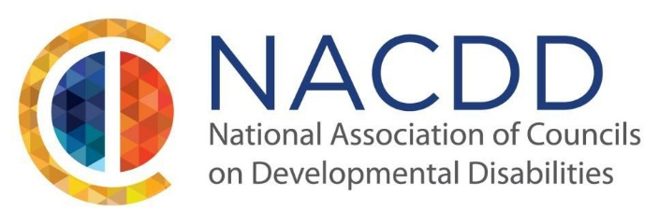

We are pleased to announce our 2023 Annual Conference:
Beyond the Conversation: It’s About Action!
July 24-27, 2023
Hilton Lake Buena Vista, Orlando, Florida

We are excited to welcome people to our in-person NACDD Annual Conference! While our conference is in-person, we recognize that the COVID-19 pandemic is still around and therefore NACDD is looking at ways to accommodate those who are unable to join us in Orlando. We will provide more information soon.

Our theme this year is Beyond the Conversation: It’s About Action! Over the last year, DD Councils have been leading the way in having conversations, many of them uncomfortable conversations, about what community inclusion looks like in a post-pandemic world. Whether we are speaking about employment, healthcare and health equity, housing, or transportation, we are deeply examining how we move beyond the conversation and take action that will change opportunities in our local communities.

NACDD invites individuals with disabilities, their families, educators, researchers, service providers, employers, policymakers, and others who support individuals with disabilities to submit ideas for sessions related to this year’s theme: Beyond the Conversation: It’s About Action! We want presentation topics that are innovative, impactful, and inspiring and are about taking action. Topics may include but are not limited to:

- Digital Inclusion and Equity
- Health Equity
- Self-Advocacy/Family Advocacy
- Community Inclusion
- Disability in the greater Civil Rights Conversation
- Disability Policy
- Innovation/Technology
- Engaging Diverse Groups
- Caregiving Workforce and Crisis
- Voting Rights

NACDD places an emphasis on having presenters who reflect the full diversity of our network of DD Councils and other partners in the field. We require proposals to feature advocates who act on issues of importance, demonstrate leadership strategies, and affect the systems that support people with disabilities – especially those with intellectual and developmental disabilities. In addition, we highly encourage sessions to be facilitated by people with and without disabilities. Your proposal must include people with disabilities to be accepted.

Attendees at NACDD’s Annual Conference includes Council members and Council staff, self-advocates, family members, federal and state government employees, corporations and businesses, non-profit organizations in the disability and civil rights communities.

All presenters are required to register for the conference. NACDD is not able to cover costs related to a speaker’s attendance to the conference. If you need financial assistance, please contact your State DD Council as they may be able to help.

If you have a proposal that supports the conference theme, please complete the submission form, and send it to conference@nacdd.org by March 31, 2023. For any questions, please reach out to NACDD staff at 202-506-5813.

